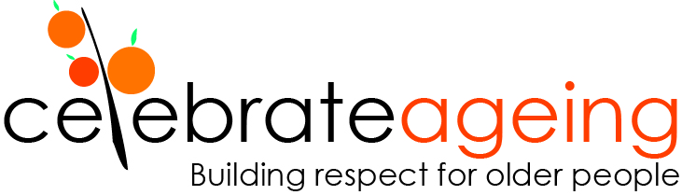

The Elder Leadership Academy
Fellowship Information

About Celebrate Ageing
Celebrate Ageing Ltd is a charity established in 2013 by Dr Catherine Barrett to challenge ageism and build respect for older people. Our work focuses on culture change and we are passionate about modelling respect for older people across all our programs.

About the Elder Leadership Academy
The Elder Leadership Academy is at the heart of Celebrate Ageing Ltd. The Academy provides Fellowships to older people to co-lead projects challenging ageism and building respect for older people. The Fellowships move beyond traditional approaches of representation, consultation, co-design and co-production - because we recognise older people have the skills and passion to co-lead change and transform their own world.

Most Fellowship address issues of marginalisation and social justice experienced by older people. Go to our webpage to read about our current and past Fellows and their achievements, at: celebrateageing.com/academy

About Fellowships
The Academy offers Fellowships to older people (65+) to address issues of mutual concern to the Fellows and Celebrate Ageing. We work in partnership with Fellows to co-lead cultural change. Fellowships are limited to older people who meet the successful applicant characteristics listed below and whose projects fit within Celebrate Ageing’s strategic plan and work capacity.

Successful applicants must have:
- An issue they wish to change
- Ideas about strategies for change
- Capacity to influence others
- Willingness to engage key stakeholders
- Passion for culture change
- Time to dedicate to making change happen
- Willingness to reflect on opportunities to improve
- Commitment to inclusion of people who are marginalised
- Commitment to work as a team
- Commitment to respect for all people
- Willingness to address their own internalised ageism.

Successful applicants will be supported to:
- Document a project plan: the need, aims, actions, outputs, expected outcomes
- Identify any sources of funding required (please note Celebrate Ageing does not have capacity to fund projects or Fellowships)
- Identify key stakeholders and allies
- Document a risk management plan
- Implement the project
- Evaluate the project
- Document a brief community report.

Funding
Please note, Celebrate Ageing does not have funding to support projects or Fellows. If funding is required for project activities, please identify sources of project funding and discuss with us how you believe funding could be sought.

Inclusion
Celebrate Ageing is committed to inclusion of people who are marginalised. This includes First Nation’s People, CALD, LGBTI, people living with dementia etc. We require that all Fellowship are inclusive of people who are marginalised.

Accessibility
We are committed to ensuring the Fellowships are accessible. If you are an older person with English as a second language, if you are Deaf, Vision Impaired, have dementia or different learning/working styles – please let us know how we can the Fellowships accessible for you.

Expectations
Celebrate Ageing values include ageing, respect, inclusion, equality and compassion. Fellows must also demonstrate commitment to these values. Celebrate Ageing reserves the right to withdraw Fellowships (including after graduation) if these values are not upheld by the Fellow.

Fellows have the right to withdraw from their Fellowship if their expectations are not met. We welcome all opportunities to clarify expectations and any opportunities to discuss concerns they are not being met.

Intellectual property
We believe it is important to profile the work undertaken by Fellows and we ask that Fellows acknowledge that their work was undertaken as part of a Fellowship with the Elder Leadership Academy. It’s about reciprocal recognition.

Before applying
Here are the questions that are included in the Fellowship Application Form. It is important that you call Academy Coordinator Dr Catherine Barrett to discuss your application before completing the application form – call 0429 582 237.

- The problem/need
  - What is the problem you have identified?
  - What else has been done to address this problem?

- Aims and objectives
  - What do you want to achieve?
  - How will you address the problem?

- Key activities
  - What are the steps that you will take?
  - What will you do?

- Risk management
  - What are risks of doing this work?
  - How will you reduce the risks?

- Stakeholders
  - Who are the key stakeholders and allies you can contact for support?
  - Who else needs to be engaged?

- Timelines
  - How long will your project take?
  - How much time will you dedicate to your project?

- Funding
  - Does your project require funding (if so, for what?)
  - What sources of funding have you identified?

- Support
  - What support do you want from Celebrate Ageing for your project?
  - What other support do you need and from whom?

- Outputs
  - What will your project produce?
  - What others see from your project?

- Outcomes
  - What do you expect will change as a result of your project?
  - How will you evaluate (measure or describe) the changes?

