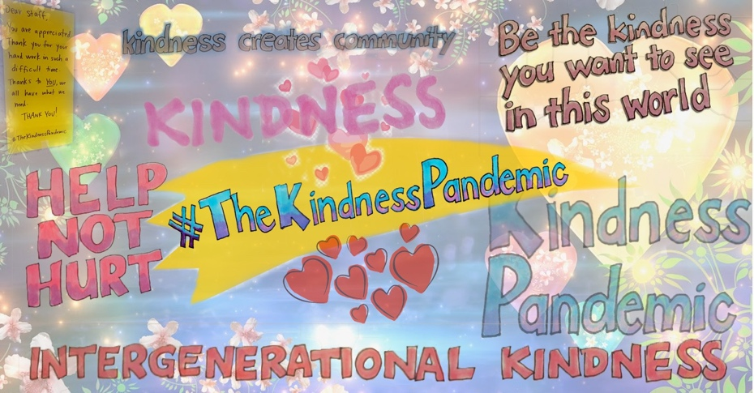

#TheKindnessPandemic

The Kindness Pandemic was established by Dr Catherine Barrett in March 2020. The Campaign is part of Celebrate Ageing, a social enterprise building respect for older people. Dr Barrett started the campaign in recognition of the impact of the Virus on older people; and in recognition of the need for kindness more broadly.

The Kindness Pandemic aims to spread kindness across the world at a time when so many people are struggling with the consequences of COVID19. In particular, Dr Barrett wants to spread intersectional kindness, or kindness for people who are marginalised (older people, people living with a disability, those who are immunocompromised) and those on the front lines of the virus (supermarket staff, health care workers etc)

A Facebook group was established for group members to share acts of kindness. Three days later the group had over 43,000 members. Thousands of people in #TheKindnessPandemic group have shared heartwarming acts of kindness for others – and commented that the Group has restored their faith in humanity.

The Kindness Pandemic is focused on a number of targeted campaigns. The first campaign was for Random Acts of Kindness in a Supermarket. This campaign arose after reports of supermarket staff being assaulted. Group members were encouraged to call or email their local supermarket to thank them for working to make sure we all have supplies. Those who were going to a supermarket were also encouraged to take in letters or posters to post around the supermarket thanking staff and calling for shoppers to be kind to staff. Over time Group members have shared beautiful posts about thanking staff, buying chocolates and then giving to staff etc and staff members breaking down because of the kindness of the gesture.

The Campaign will add a focus on kindness for health care workers shortly, then older people and will continue identifying new campaigns.

MORE INFORMATION
Contact Dr Catherine Barrett on 0429582237 or director@celebrateageing.com
Webpage: https://www.celebrateageing.com/the-kindness-pandemic.html

