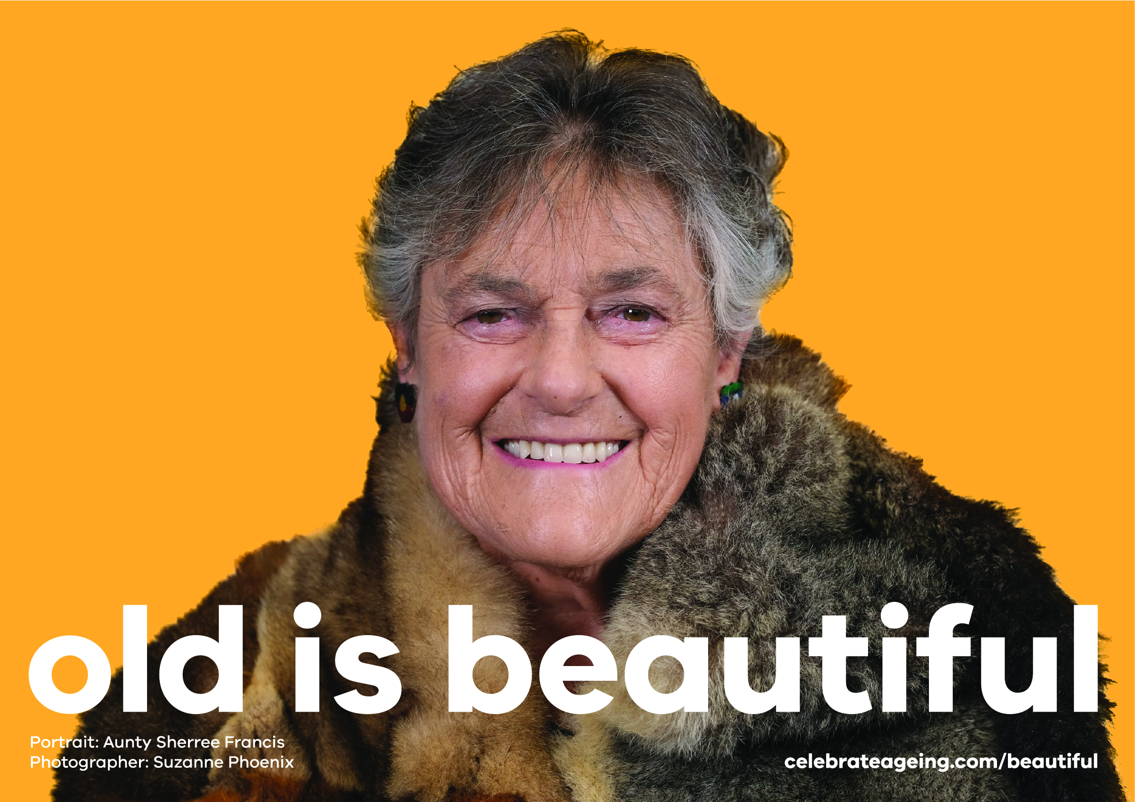

Old is beautiful project launches for
International Day of the Older Person (October 1st)

In a world first this International Day of the Older Person (IDOP) a national project will be launched to combat ageism and build respect for older people. The project will include displaying 100 large posters around Melbourne – with a portrait of Wurundjeri Elder Aunty Sherree Francis who said:

When you become older you appreciate who you are with much more authenticity. This is me it says. I am a First Nation Elder with wisdom and knowledge to share with the younger generations. My journey is slowly ending, everything is beautiful through my eye. I am beautiful. I leave this legacy to my daughters, granddaughters and future generations of granddaughters.

Ageism has devastating impacts on older people and adverse effects our health care system, workplaces, the economy and our culture. Global research shows 1 in 2 people are ageist towards older people and ageism:

- costs around $63 billion annually in health care costs (Global data)
- costs $850 billion annually in workplace discrimination (Global data)
- costs $10.9 billion in financial abuse/fraud annually (Australian data)
- can reduce life expectancy by 7.5 years (Global data)
- underpins the Elder Abuse experienced by 14% of older people (Australian data)

The #OldisBeautiful project includes workshops for older people to explore what beautiful means to them – and to document their photo portraits for sharing on social and other media.
The project is an initiative of Celebrate Ageing Ltd, a charity combatting ageism and building respect for older people. Pilot coordinator and Director of Celebrate Ageing Ltd Dr Catherine Barrett said:

The workshops create uplifting spaces for older people to build a positive self-image by exploring what beautiful means to them. We call this ‘hair and make up for the soul’ because you can feel people’s spirits lift as we reclaim beautiful for all ages – and that influences what they take to the photo shoot.

We invited older people to participate to build their self-confidence and combat ageism in the community. It was interesting to see how many older women wanted to participate because they were concerned about body image for their grand daughters and wanted to role model the valuing of ageing and imperfection.

The Victorian pilot is a partnership with Elder Rights Advocacy, an organisation promoting the human rights of older Victorians, who recognise the role of the campaign in primary prevention of Elder Abuse. CEO Debra Nicholl said:

The #OldisBeautiful project challenges the messages sent by the Fashion and Beauty Industry that we are less beautiful and of less value as we age. This is an innovative approach to of building the confidence of older people – and educating the community about valuing older people and valuing our own ageing. These are important steps in primary prevention of Elder Abuse.

Project photographer Suzanne Phoenix said:

#OldisBeautiful is an opportunity to create very real and powerful photographic portraits in a safe and supportive space. The portraits are not modified, there is no photoshopping or making faces black and white to highlight wrinkles. I relish the chance to make portraits where the person isn’t directed to portray any particular feeling or emotion, they can be whoever they want to be and show us what ‘beautiful’ means to them.

The release of Project portraits will begin in the week building up to IDOP before the release of a series of urban street posters featuring Aunty Sherree Francis.

More information
- Aunty Sherree is happy to speak with media
- webpage: celebrateageing.com/beautiful
- Dr Catherine Barrett 0429 582 237 or director@celebrateageing.org
- Debra Nicholl debra.nicholl@era.asn.au
- Suzanne Phoenix suzannephoenixphotography@gmail.com

